MGMS – Create Project

Functional Specification Document

Ver. 1.4

Version History
Version # | Date | Description
1.0 | 12-Oct-2010 | First draft
1.2 | 28-Oct-2010 | Added validation check error messages
1.3 | 15-Nov-2010 | Removed “active_yes_no” fields
1.4 | 03-Dec-2010 | Label changes in Project Info & Allocation screens

Table of Contents

Version History 2
1 Introduction 4
1.1 Purpose 4
1.2 Scope 4
1.3 Assumptions 5
1.4 Constraints 5
2 Projects 5
2.1 Add Projects 5
2.2 Projects List 12
2.2.1 Edit Projects 13
3 Business Rules 14
4 Status Messages 15

Introduction

Purpose

This document provides the requirements and functional specifications for the feature of project creation in the Multisite Grant Management System project.
This is not a project plan or a design document. It is a guide for system architecture and development, not for phasing, timelines or deliverables.
Finally, this is a ‘living document’ and the specification will change, continuously, as the project proceeds. More details will be added and the existing information edited as the requirements, scenarios and use cases evolve in the course of the project.

Scope

The site admin can create new projects for the institution. The key associated activities are:
- Saving the project details (which may be updated any number of times) - project name, code, type, Principal Investigator, Project Start & End Dates.
- The details saved are – name and role (co-PI).
- There is an option for the institution to assign the created project to particular departments.
- The detail saved is the department name, selected from the list of departments made available.
- Editing/updating may be done any number of times
- While creating a project, a grant allocation is created automatically with a default amount of zero. The site admin can update with the actual grant amount the institution is allocating for the created project (self-fund). Here, the Institution is the owner of the project.
- The details saved are – amount allocated, and any remarks from the user.
For the institution site admin (& privileged users), there is provision to view all its current projects in a single list, from which the user may navigate to any project’s home page.

Currently a new project can be created by an institution when it is self-funded. For all cases where an institution is granted a project, the grantor institution saves the project details in the MGMS in its Sub project Allocation section, assigning it the grantee (recipient). The grantee, on logging into the MGMS sees this project in the Current Projects List. The grantee has the privilege to edit the project details.

Assumptions

It is assumed that in all the scenarios, the grantor and the grantee (and any sub-grantees) are all using the MGMS application.

Constraints

Projects

Add Projects

Screen & Control Description

Any project created through this screen is automatically associated with the party with whose log-in details the user had logged into this application.

Figure 1: Create Project
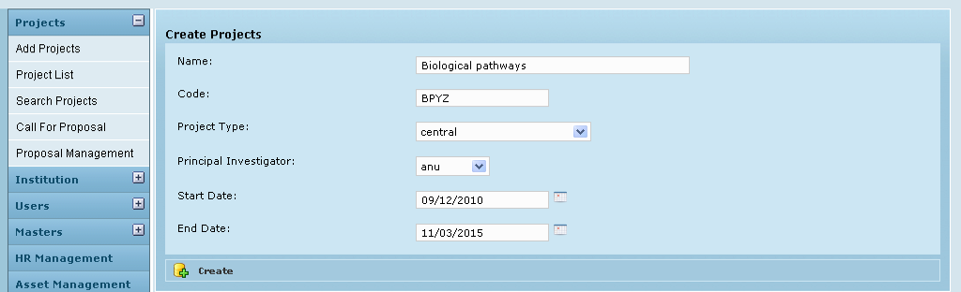

Field /Label | Input-Control | Data Type | Details
Create Projects
Name: | Textbox | String
Code: | Textbox | String
Project Type: | Listbox | String;
Principal Investigator: | Listbox | String;
Start Date: | Calendar | String; datetime
End Date: | Calendar | String; datetime
Active: | Listbox | Char(1)
Create | Button |  | On clicking, same screen refreshed with details displayed in their fields and a message “Project created successfully”  3 new buttons appear at the top – “Additional PI”, “Add Department”, “Fund Allocation” (Image below)

Figure 2: Create Project - Success Message
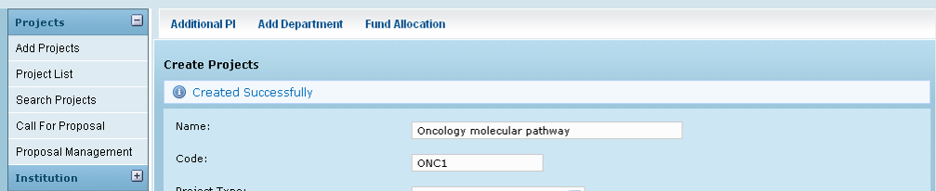

Additional PI

Through this screen, any number of co-Principal investigators may be added to a project, one after another. The name can be selected from a drop down list which is populated base on the list of names given in the master table.

Figure 3: Add Projects to PI
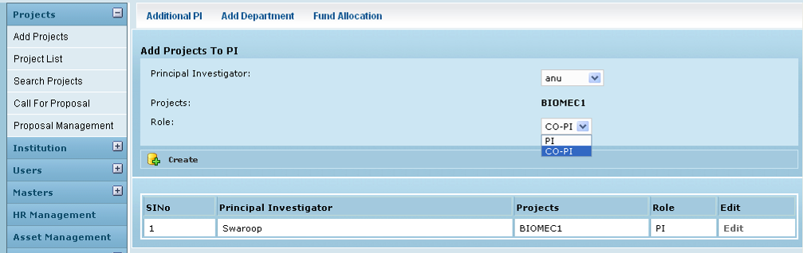

The table displays as first row, the details of the PI that were saved from the Create Project screen. All subsequent entries on Co PIs for the project are displayed below this row.

Field /Label | Input-Control | Data Type | Details
Additional PI | Button | Additional PI screen opens up
Add Department | Button | Add Department screen opens up
Fund Allocation | Button | Fund Allocation screen opens up
Add Projects to PI
Principal Investigator: | Textbox | String
Projects: | Autopopulated | String | Display project code
Role | Listbox | String
Create | Button |  | On clicking, the same page refreshes with message – “Project updated successfully”
Sl No | Auto populated
Principal Investigator: | Auto populated | String
Projects: | Auto populated | String
Role | Auto populated | String
Edit | Link |  | Opens the Edit screen

Edit Projects PI Map

Figure 4: Edit Projects PI Map
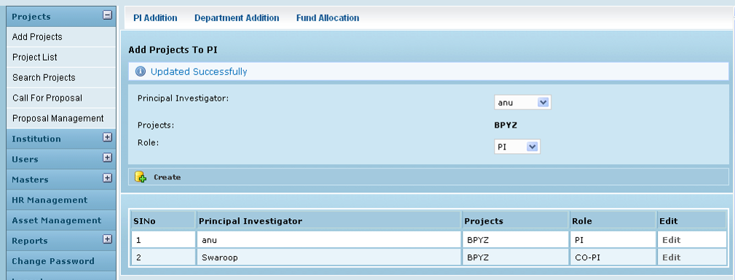

Field /Label | Input-Control | Data Type | Details
Add PI | Button | Add PI screen opens up
Add Department | Button | Add Department screen opens up
Fund Allocation | Button | Fund Allocation screen opens up
Edit Projects PI Map
Principal Investigator | Auto populated | String;
Projects | Auto populated | String;
Role: | Auto populated | String
Active: | Listbox | char(1)
Update | Button |  | On clicking, the same page refreshes with message – “Project PI map updated successfully”

Add Department

A project may or may not be mapped with different departments of the institution.

At present this relationship does not play an active role ion the workflow of MGMS.

Figure 5: Add Projects to Department
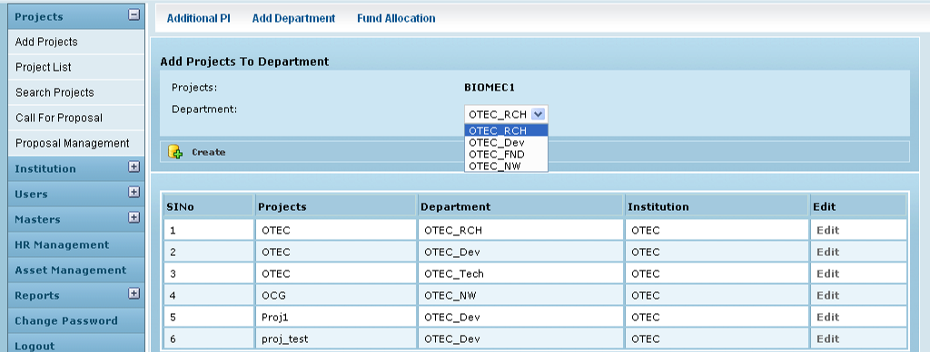

Control Description

Field /Label | Input-Control | Data Type | Details
Additional PI | Button | Add PI screen opens up
Add Department | Button | Add Department screen opens up
Fund Allocation | Button | Fund Allocation screen opens up
Add Projects To Department
Projects: | Auto populated | String;
Department: | Listbox | String;
Create | Button |  | On clicking, same screen refreshed with details displayed in their fields and a message “Created successfully” . Also, the details are populated as the bottom most line item in the table below the fields. Here again, a message “Created successfully” – is displayed
SlNo | Auto populated
Projects | Auto populated | String;
Department | Auto populated | String;
Institution | Auto populated | String;
Active | Auto populated | char(1)
Edit | Button |  | On clicking, the “Edit Projects Department map” page opens

Edit Projects Department Map

Screen & Control Description

Figure 6: Edit Projects Department Map
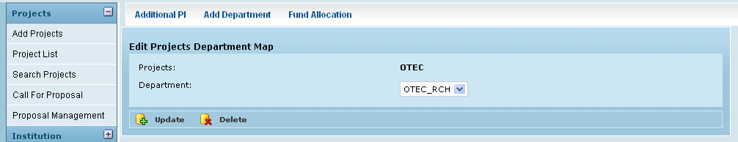

Field /Label | Input-Control | Data Type | Details
Add PI | Button | Add PI screen opens up
Add Department | Button | Add Department screen opens up
Fund Allocation | Button | Fund Allocation screen opens up
Edit Projects Department Map
Projects: | Auto populated | String;
Department: | Listbox | String;
Active: | Listbox | char(1)
Update | Button |  | On clicking, the same page refreshes with message – “Project department map updated successfully”

Fund Allocation

Since the project is created by the institution itself, it is understood that the project is self-funded. The details are saved on the screen that is opened by clicking Fund Allocation.

Figure 7: Fund Allocation - Self Fund
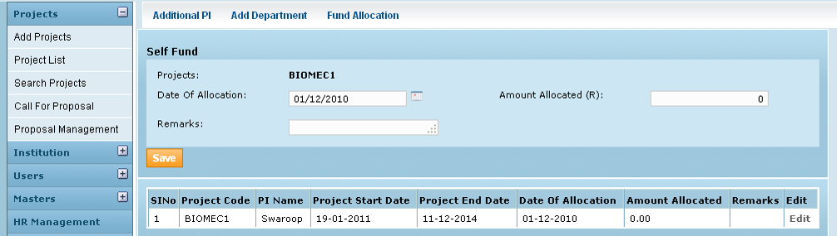

Field /Label | Input-Control | Data Type | Details
Additional PI | Button | Add PI screen opens up
Add Department | Button | Add Department screen opens up
Fund Allocation | Button | Fund Allocation screen opens up
Self Fund
Projects: | Auto populated | String | Displays the project code
Date of allocation: | Calendar | Date | Valid check: prevent user from saving a record with a date value in this field that is earlier to the project start date
Amount Allocated (R) | Textbox | Number | Default display- zero Valid check: Valid check: prevent user from saving a record with a zero value in this field.
Remarks: | Textarea | String
Save | Button |  | On clicking, same screen refreshed with details displayed in their fields and a message “Created successfully” . Also, the details are populated as the bottom most line item in the table below the fields.
(Table fields)
SlNo | Auto increment populated
Project Code | Auto populated | String
PI Name | Auto populated | String
Project Start Date | Auto populated | date
Project End Date | Auto populated | date
Date of Allocation | Auto populated | String
Amount allocated | Auto populated | Number
Remarks | Auto populated | String
Edit | Button |  | On clicking, the “Edit Grant Allocation” page opens

Edit Grant Allocation

Screen & Control Description

Figure 8: Edit Grant Allocation
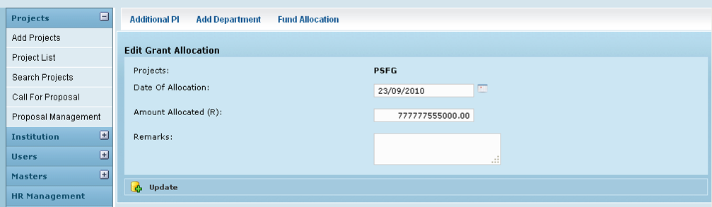

Field /Label | Input-Control | Data Type | Details
Add PI | Button | Add PI screen opens up
Add Department | Button | Add Department screen opens up
Fund Allocation | Button | Fund Allocation screen opens up
Edit Grant Allocation
Projects: | Auto populated | String
Date of Allocation: | Calendar | datetime
Amount allocated (R) | Textbox | Number
Remarks | Textarea | String
Update | Button |  | On clicking, the same page refreshes with message – “Grant Allocation” updated successfully”

Projects List

When a site admin /privileged user logs into the GMS, “Projects List” is the home page by default and it lists out all the currently active projects in the user’s institution, and their details.

Screen & Control Description

Figure 9: Projects List
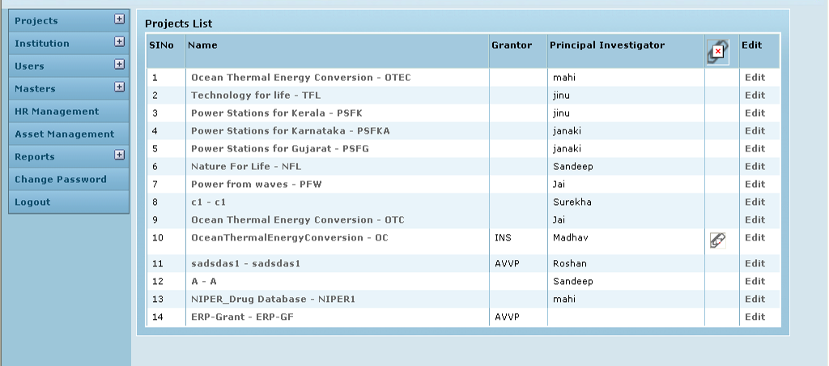

Projects List Table

Field /Label | Input-Control | Data Type | Details
SlNo | Auto-populated | Auto-increment | Auto-increment
Name | Auto-populated, hyperlink | String
Grantor | Auto-populated | String
Principal Investigator | Auto-populated | String;
Attachments | Icon | Image
Edit | Button |  | On clicking, the “Edit Project” page opens

Clicking on each project name in the Projects List Table, will take the user to the specific project’s home page – Project Info page – discussed in a separate document

The other options to be filled in mandatorily while creating a project are:

Edit Projects

Screen & Control Description

Figure 10: Edit Project
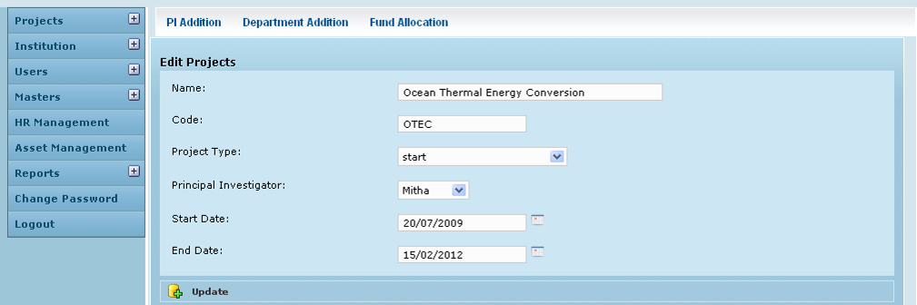

Field /Label | Input-Control | Data Type | Details
Add PI | Button | Add PI screen opens up
Add Department | Button | Add Department screen opens up
Fund Allocation | Button | Fund Allocation screen opens up
Edit Projects
Name: | Textbox | String
Code: | Textbox | String
Project Type: | Listbox | String
Principal Investigator: | Listbox | String
Start Date: | Calendar | datetime
End Date: | Calendar | datetime
Active: | Listbox | char(1)
Update | Button |  | On clicking, the same page refreshes with message – “Project updated successfully”

The buttons Additional PI, Add Department and Grant Allocation enable adding to/editing the further details of the project, as explained in the sections above.

Business Rules

- A project can have only a single Principal Investigator at a time.
- The institution can assign any number of Co-PIs to the project after project creation.
- Any number of departments may be associated with a project.
- While creating a project, a grant allocation is created automatically with a default amount of zero
- Any number of grant allocations can be made during the project period by the institution
- An allocation can never be deleted.
- An allocation cannot be edited after sub-project allocation

Status Messages

Sl No | Status Message
1 | Created Successfully
2 | Updated Successfully
3 | Deleted Successfully
4 | The Requested Record Not Found
5 | The Record can't be deleted, Already in use
6 | The Record Already Exists
7 | Please Enter a valid email address
8 | You can not delete yourself, please login as another admin and try again
9 | file cannot be empty
10 | File uploaded successfully
11 | The Requested File Not Found
12 | The File can't be deleted, Already in use
13 | Cannot upload a .exe file
14 | Attachment Type not found
15 | is already assigned as Investigator for this project
16 | Grant allocation done for the project. So can not be deleted
17 | Project can not update,
18 | You are not authorized to access this project
19 | Please Enter Name
20 | Please Enter Code
21 | Please enter the Project Type
22 | Please enter the Investigator
23 | Project End Date should be greater than Start Date
24 | Please enter the Amount Allocated
25 | Please select the Department
26 | Allocation Date should be greater than Project Start Date
27 | Invalid Amount

